Courier Database Management System

SANGAM LUDHANI

KSHITIJ SANKESARA

Project Summary:

This project focuses on designing a database for a Courier delivery organisation. A large chunk of data is gathered by courier companies right from start (pickup) to transportation and until final delivery. This data includes important details about the customer, type of package, target location etc. Hence, there are numerous data records for different type of parcels and there is a need to effectively manage this data by building a database where all relevant information can be stored.

The database system proposed by us in this report records information in different tables as can be seen in the ERD diagram. This diagram is prepared in the analysis phase of the project as per the business requirement of such courier companies. This proposal basically incorporates three important aspects of courier delivery i.e. Status tracking, Route chosen and pricing information. The tables will record information of all the customers, parcel, rates, price calculation, warehouses, etc.

This system would be structured in a way that all the information will be in table format whether it is the warehouse details info or the route chosen info etc. The purpose of this system is to increase automation and reduce manual effort by giving features like price calculation and self-tracking of the parcel.

The customer needs to come and drop in the package at one of the service stations. Each package will have a unique id through which its status can be tracked. The route will be chosen on basis of target destination zip-code in the table parcel. Route details table will have the mapping of warehouseID and Zipcodenumber. This is the basic overall process and flow is this database system.

Important points and features that this design incorporates are as mentioned below:

* Total distance to be covered will be calculated on basis of source and target zipcodes.
* 3 types of delivery type can be chosen (Normal, speed and express).
* Pricing information will be calculated on basis of the delivery type chosen, total weight of the package and total distance to be covered.
* The route will be chosen on basis of zipcodes covered by the warehouse.

This report includes details about the design of the proposed database system in form of entity relationship diagram (ERD). All tables in this database system have been mentioned along with their functional description and usage. Metadata of tables (key, attributes and fields) have been described in the section of entities and attributes. This report addresses the needs of the courier company in form of business rules and contains all relevant information that may be required by the users of this system.

Business Rules:

1. Route will be chosen based on the zipcodes covered by warehouse mentioned in the table Route details.
2. Depending on standard rates, pricing of the package will be decided.
3. Delivery type of parcel can be of 3 different types i.e. normal, speed and express
4. Every package will have a single pricing based on the total distance, total weight and delivery type chosen.
5. In status tracking table, if package status is a failure then field reason of failure needs to be updated.
6. One customer can send one or more packages to different destination.
7. Every package would have a unique id based on which its status can be tracked and pricing can be seen.

Entity And Attribute Table:

1. Customer – This entity captures information about the customers who uses the courier services.



1. Package – This entity captures information about the package which is to be delivered.



1. Standard Rate – This entity captures information about the rate of the package which depends on various parameters.



1. Pricing – This entity gives information about the final price of the package.



1. Warehouse Details - This entity captures information about the Warehouses.



1. Route Details – This entity captures information about the zipcodes which are covered by a particular Warehouse and assigns the Route Numbers.



1. Status Tracking – This entity is used to indicate the route of the package and to track the status of the package.



1. Zip Code Details – This entity shows all the ZipCodes and the City in which it is situated.



Entity – Relationship Diagram:



Database System Infrastructure:

* Database Engine: SQL Server (Here Tables, Joints, Stored Procedures and Trigger are created)
* Interface Design Tool: Microsoft Access (Here Forms and Reports are created)
* Entity-Relationship Diagram: Microsoft Visio

Creating Tables:

1. ZipcodeDetails –

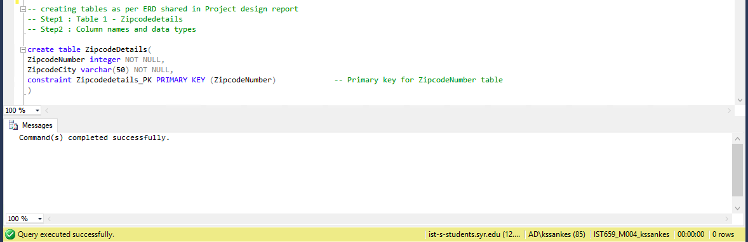

1. CustomersDetails –

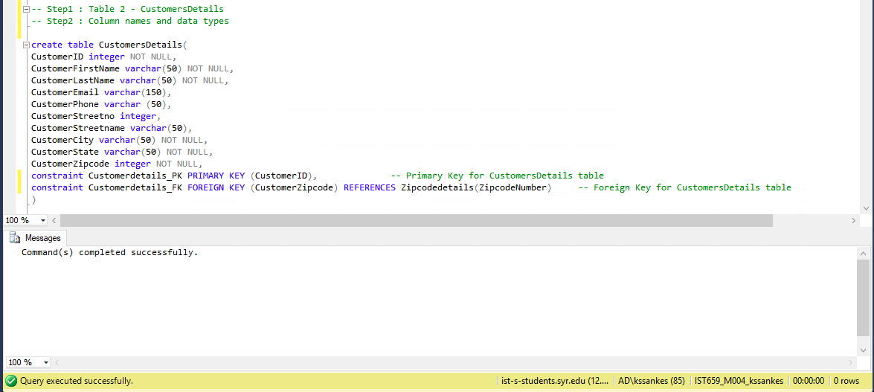

1. StandardRates –

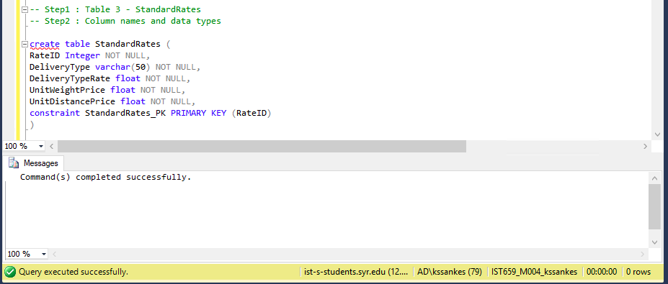

1. WarehouseDetails

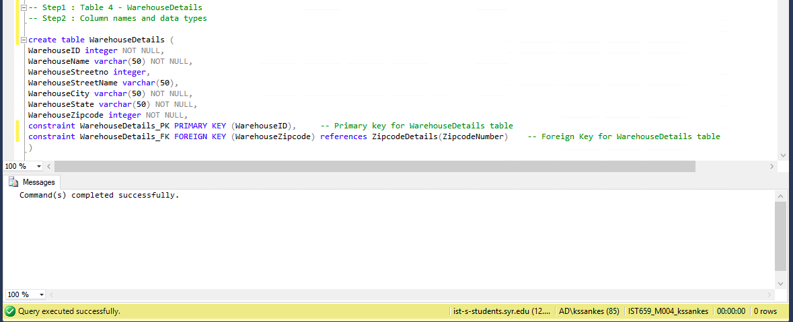

1. RouteDetails

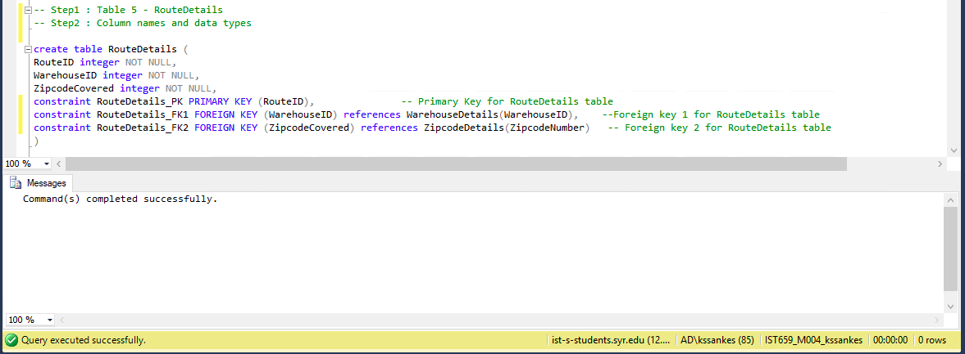

1. ParcelDetails

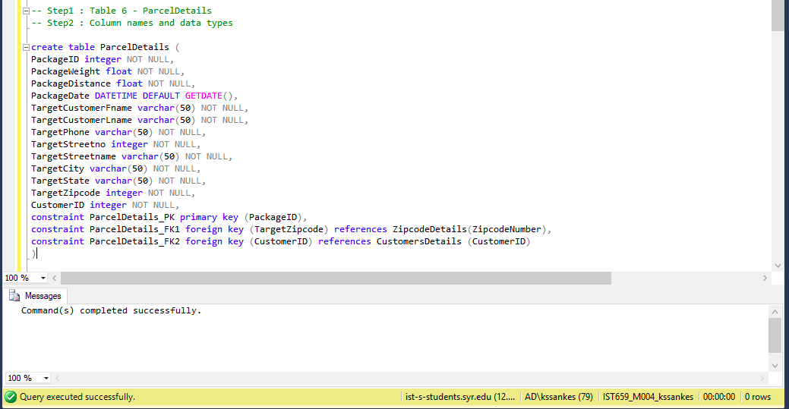

1. StatusTracking

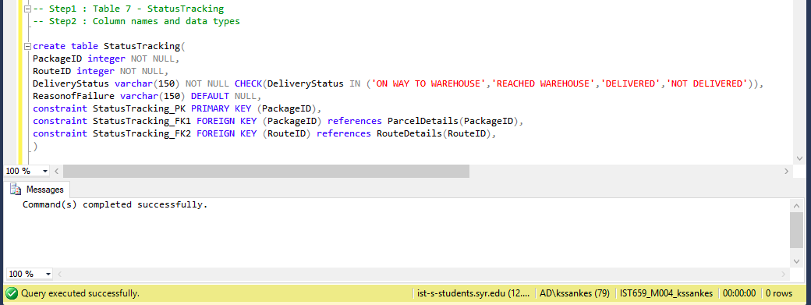

1. Pricing Details

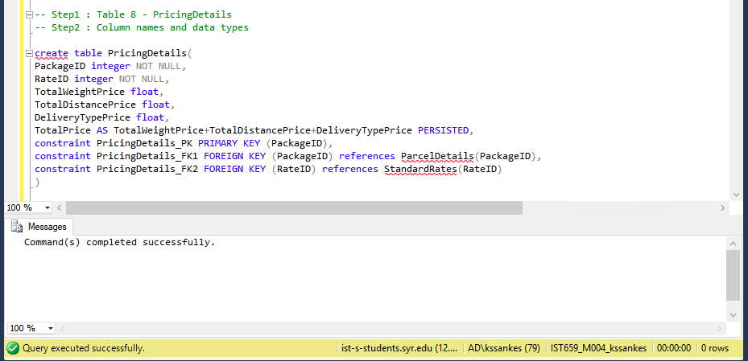

Inserting Data:

1. ZipcodeDetails -

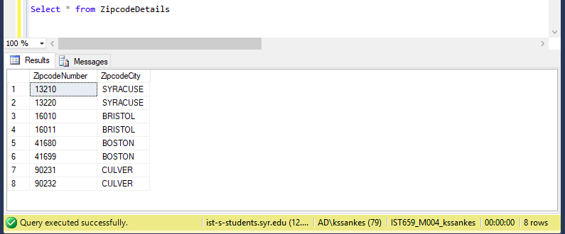

1. CustomersDetails –

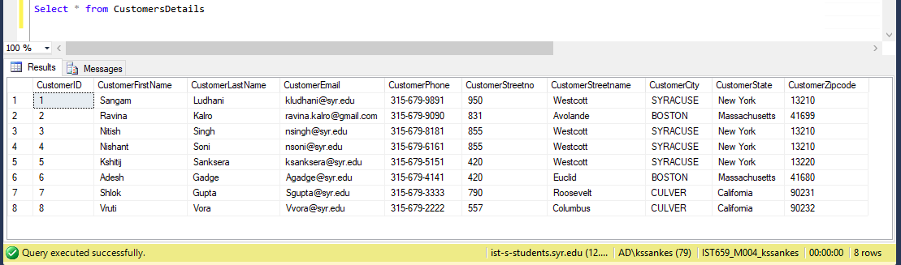

1. StandardRates –

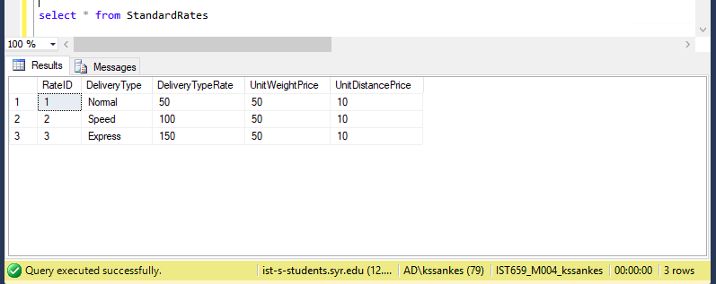

1. WarehouseDetails –

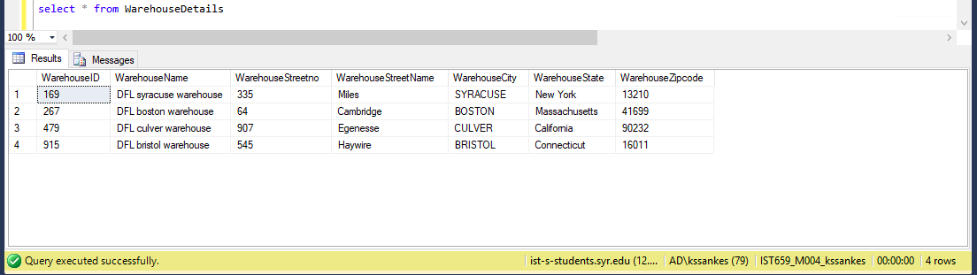

1. RouteDetails –

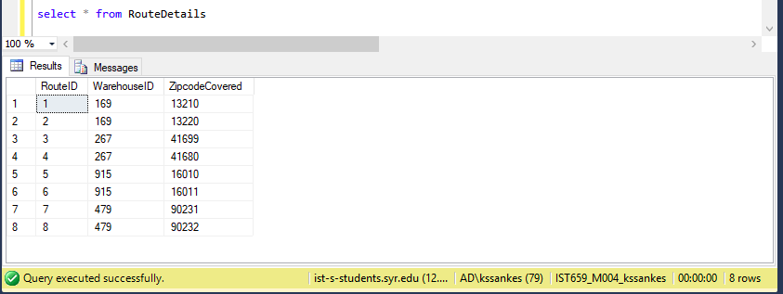

1. ParcelDetails –

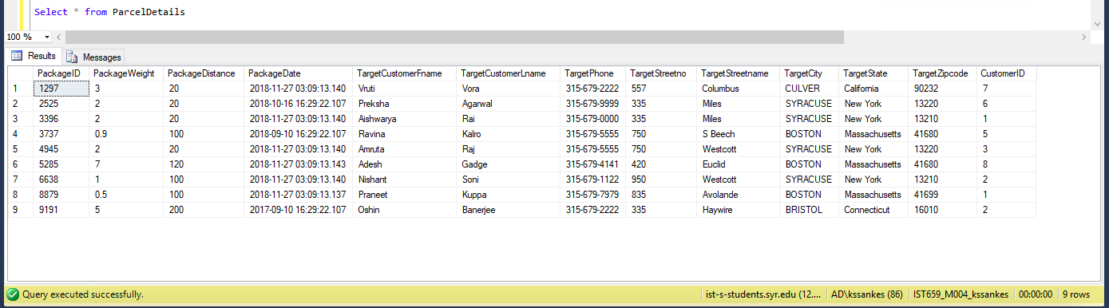

1. StatusTracking –

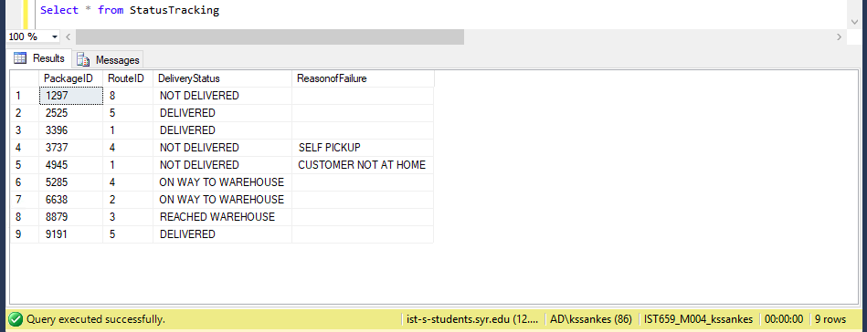

1. PricingDetails –

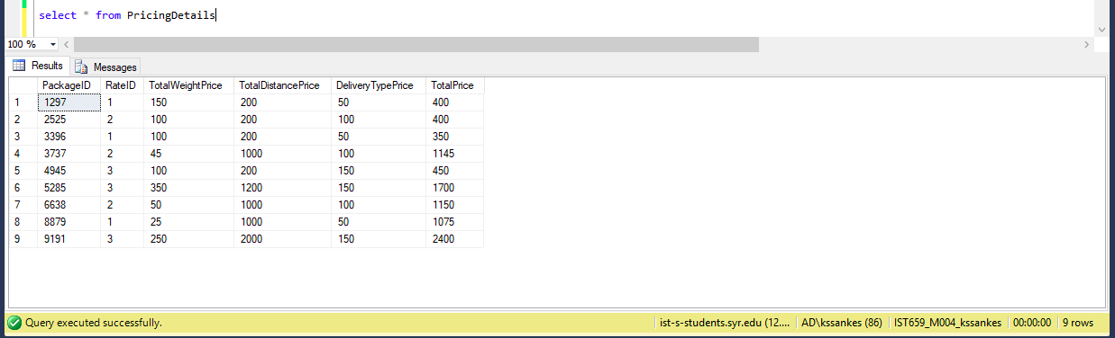

MAJOR DATA QUESTIONS:

1. Track the status of all package in the month of November

-- First applying inner join to combine 2 tables of ParcelDetails and StatusTracking using common row of PackageID

-- Second, applying where clause to select the month as November or 11

-- Third, selecting the specific columns to be displayed from both the tables

-- Below query are written in 2 forms, one considering month as numerical (11) and second as string (November)

--Query1:

select p.PackageID, p.CustomerID, s.DeliveryStatus, s.ReasonofFailure

from

ParcelDetails as p inner join StatusTracking as s on p.PackageID = s.PackageID where month(p.PackageDate) = (SELECT MONTH('November' + '26 2018'))

--Query2:

select p.PackageID, p.CustomerID, s.DeliveryStatus, s.ReasonofFailure

from

ParcelDetails as p inner join StatusTracking as s on p.PackageID = s.PackageID where month(p.PackageDate) = 11

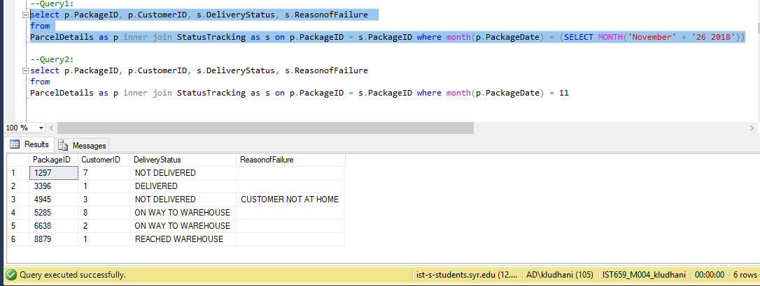

1. This question has 2 sub parts,

* Total revenue made by Courier Company in year 2018
* Calculate city wise revenue made by company

For first part,

-- First, applying inner join to combine 2 tables of ParcelDetails and PricingDetails using common row of PackageID

-- second, Data categorization by using group by on year and used order by decreasing

-- third, selecting aggregate functions on Total Price to display revenue year wise for business

select year(p.PackageDate)'Year', sum(price.TotalPrice)'Total Revenue'

from

ParcelDetails as p inner join PricingDetails as price on p.PackageID = price.PackageID group by year(p.PackageDate) order by year(p.PackageDate) desc

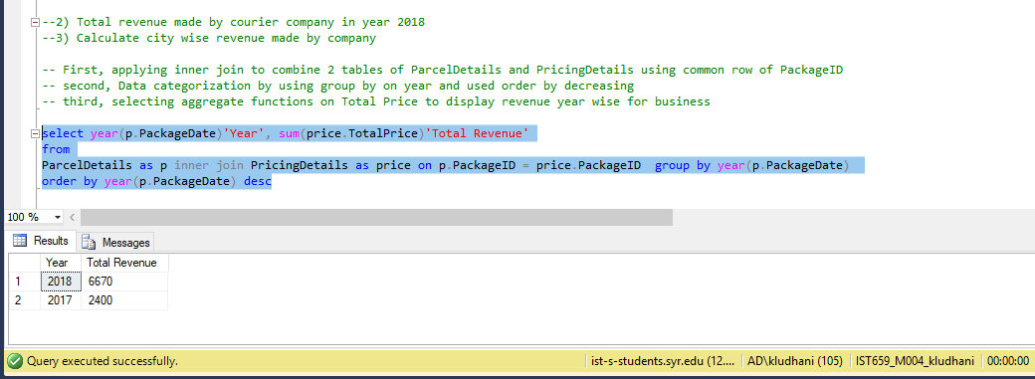

For second part,

-- First, applying inner join to combine 2 tables of ParcelDetails and PricingDetails using common row of PackageID

-- second, Data categorization by using group by on City and then selecting aggregate functions on Total Price

select p.TargetCity, sum(price.TotalPrice)'Total Revenue'

from

ParcelDetails as p inner join PricingDetails as price on p.PackageID = price.PackageID group by p.TargetCity

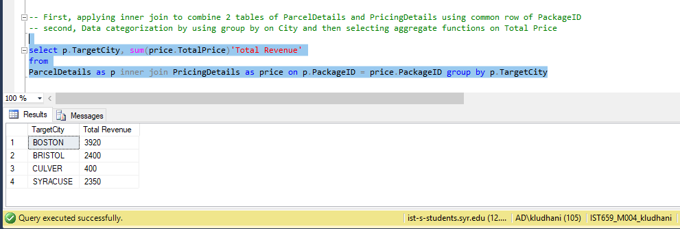

1. find the routes/zipcodes (where the company operates) but usually no packages are being sent

-- First, find unique zipcode values from ParcelDetails table where packages are being sent

-- Second, perform inner join in RouteDetails table and Zipcodedetails table to merge zipcodes covered by company, city name, route id

-- use NOT IN clause to find which routes/zipcodes usually parcel are not sent to

Select \*

from RouteDetails as r inner join ZipcodeDetails as z on r.ZipcodeCovered = z.ZipcodeNumber where r.ZipcodeCovered NOT IN

(select Distinct(p.TargetZipcode) from ParcelDetails as p)

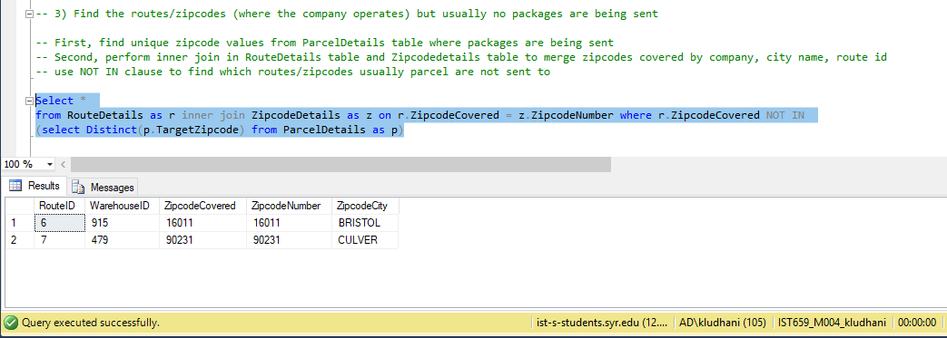

1. Busy warehouses with total count of packages it is receiving & total revenue it is generating for company

* Also, created Report on this view in Access (by importing the view from SQL server in Access)

-- First applying inner join to combine 2 tables of ParcelDetails and StatusTracking using common row of PackageID

-- second applying inner join to combine resultant table from first point and RouteDetails table using common row of routeid

-- third applying group by command to categorize data in warehouses

-- Fourth, selecting the specific columns to be displayed from all tables

-- Fifth, creating the view for this query

create view WarehouseReporting as

select w.WarehouseID , w.WarehouseName, w.WarehouseCity, sum(price.TotalPrice)'Total revenue', count(p.PackageID) 'Total no of Packages'

from

ParcelDetails as p inner join StatusTracking as s on p.PackageID = s.PackageID

inner join PricingDetails as price on p.PackageID = price.PackageID

inner join RouteDetails as r on s.RouteID = r.RouteID

inner join WarehouseDetails as w on r.WarehouseID = w.WarehouseID group by w.WarehouseID, w.WarehouseName, w.WarehouseCity

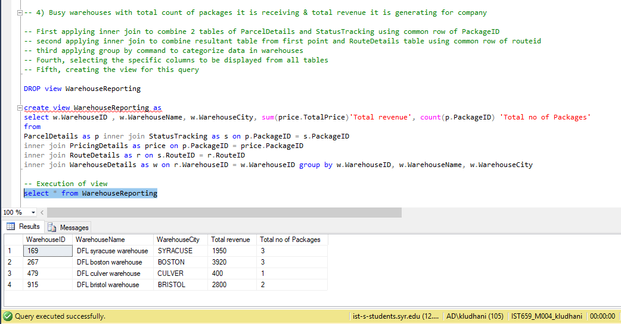

* Below report indicates the revenue figures a warehouse is earning by serving customers in a particular city and routes

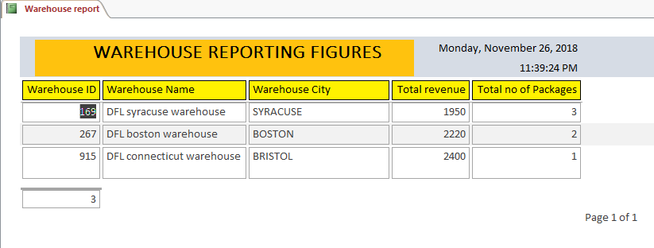

INTERFACES:

1. Customer and Package details form

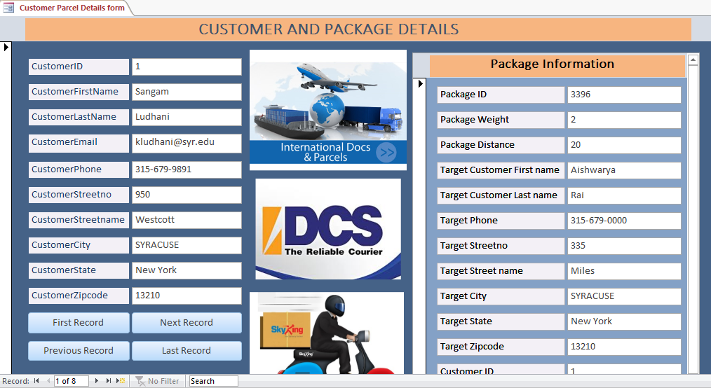

1. Package-Standard Rate Card- Pricing of Parcel form





4)

